1000 E. Victoria Street, Student Services Center Rm 1401
Carson, CA 90747-0005
(310) 243-3353 ∙ Fax (310) 243-3131
Credential Request Instructions
(SMApply web portal)
Steps to begin the Online Credential Request Process, READ CAREFULLY:
Eligibility for a credential recommendation is based upon completion of all components of your program. Being placed in an assignment or even completing student teaching will not guarantee recommendation for the credential if other requirements are not met. All exams, assessments, coursework outside of CSUDH, etc. must be completed prior to submitting a credential request.
As soon as it is determined that all requirements have been met, you are required to scan and upload documentation as evidence of completion of program components including (CSUDH transcripts, Basic Skills/CBEST, Subject Matter verification, employment verification/experience, passage of RICA, CalAPA, etc…) into SMApply web portal. Credential Analyst will analyze your documentation to determine if you have met all of your program requirements. If you have completed all of the credential components then you will be recommended for your credential document.
Once the credential has been recommended you will receive an email from CTC requesting to pay the $102.50 application processing and complete the Personal and Professional Fitness questionnaire. If additional documentation is required, you will be notified via email by the Credential Office and/or the commission. Fee payment must be made within 90 days of the recommendation date or CTC will cancel the recommendation. A few days after making your payment, CTC will forward a payment confirmation number to you. Provided that there are no extenuating circumstances, CTC will then send you an e-mail confirming that the credential has been granted. You will receive one additional e-mail notice which will provide the details of your credential. This final notice is the one you will use for employment purposes. Your credential and all information pertaining to such will appear as granted on the CTC website.
You will be kept informed of your application status all throughout the process via email (also check your spam and/or junk mail).
HOW TO APPLY
- Visit our website https://csudh-coe-cred-recom.fluidreview.com/
- Log In or Register (Create Account)
- Select the Credential Program Request type: Example: Multiple Subject, Single Subject, Special Education, Administrative services credential etc…)
- Please click on ToroPay link to pay $50 processing fee, then scan and upload a copy of your complete receipt. This is a separate fee from your initial COE Admission Processing Fee and is non-refundable. Credential Requests will NOT be processed until the fee has been submitted.
- Scan and upload requested documentation, once you have completed all required tasks submit Credential Request. NOTE: WHEN UPLOADING OFFICIAL TRANSCRIPTS, YOU MUST UPLOAD ORIGINAL TRANSCRIPT. IF SCANNED TRANSCRIPTS ARE NOT LEGIBLE YOU WILL BE REQUIRED TO RESUBMIT THE ORIGINAL OFFICIAL TRANSCRIPT.
- After you have completed this process you will receive an email recommendation or pending/denial notification.
- If you experience difficulties creating an application, click on the right hand corner  help with using SurveyMonkey Apply.
- Questions: Contact COE Student Services Center office @ 310-243-3525.

Within two weeks, the Credential office will verify the required documentation and if eligible the Credential Analyst submit the online recommendation to CTC. You will be notified via email “Notice of Recommendation for New Document” from CTC recommending you for a new credential document with instructions to complete the “Professional Fitness” questionnaire and payment portion of this process. CTC’s processing system requires a valid email address and debit/credit card to complete this step. Shortly after making your credential payment and provided that there are no extenuating circumstances CTC will then send you an email confirming that the credential has been issued (usually within 15 days).

How do I create a new application?

I haven't created an application yet
If you have no Applications created yet, within the site you can:
- Click View Programs
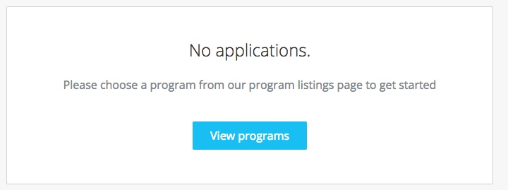
- You may need to complete an Eligibility Quiz if required by the site.
- Once you've completed the eligibility quiz, or if there is no quiz enabled, you will be able to View the programs.
- Click MORE > for the program you wish to apply for
- Click Apply
Based on site configurations put in place, you may not be able to create an application for a program.
In the case where you've already created an application on the site and wish to create a new one:
- Click Programs in the top in the top right corner
- Click MORE > for the program you wish to apply for
- Click Apply
How do I submit my application?
To be able to submit your application you will first need to complete all required tasks within your application. Additionally, you will need to ensure that you've verified your email.
A Banner will appear within your portal until you've verified your account. Click to Send Verification Link and follow the instructions sent in the email.
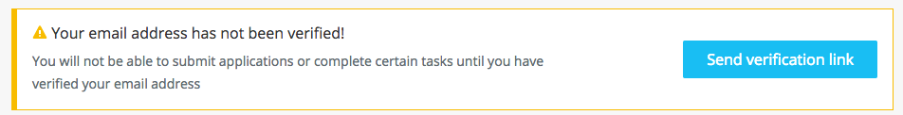
Once all tasks are complete, submit your application by performing the following steps:
- Within the application to submit, select Review & Submit
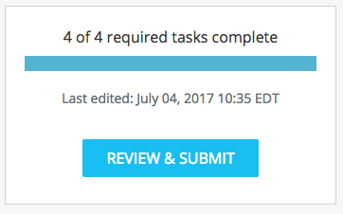
- Review application materials
- Once you've reviewed all your completed tasks, you can click to Submit Your Application.
- Choose to proceed back to your applications or View More Programs.

How do I preview my application?
There are two ways to Preview your application within the site:

From the My Applications Page
- Click on the More Options icon in the top right corner of the tile of the application you wish to Preview
- Select Preview

From Within the Application
If you're on the application page with the list of Tasks to complete, to preview your application:
- Click on the More Options icon in the top right corner of the application.
- Select Preview

How do I edit a completed task?
If you have previously pressed Marked as Complete on a form, but have not yet Submitted your application, you can choose to make Edits to your task.
- Enter your application
- Click on the task you wish to edit
- Click on the More Options icon in the top right corner of the task
- Click Edit
- Click Previous/ Next to navigate between the pages and make your changes
- When done, navigate to the last page and press Mark as Complete
If you experience difficulties editing your task or this option isn't available, see Why can't I edit my task?
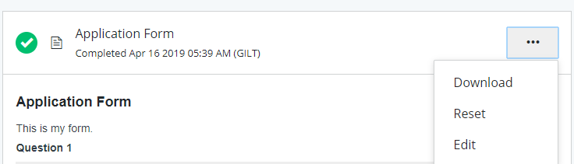

Why can't I edit my task?
If your tasks Cannot be Modified or say The task cannot be started at this time, there are a few main reasons why this could occur.
- The deadline has passed or the administrators don't want you to start until a specific date.
- Prerequisites haven't been met. Meaning you will need to complete other tasks before you're able to start this one.
- You've completed your task and the administrators don't wish for you to be able to make changes.
- Your application is locked.

I get an error when uploading a file
There are a few potential reasons why you may experience issues uploading your file:
- The file isn't in an available format.
Check to ensure that the file type you're trying to upload matches the requested formats.
- The file is encrypted
SurveyMonkey Apply won't accept encrypted files. To upload your file, it will need to be unencrypted (photocopy original first then scan).

